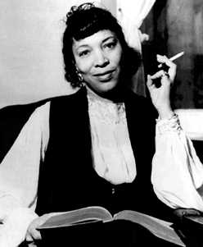 **Hurston, Zora Neale (1891 – 1960**)

SUMMARY

Zora Neale Hurston was a writer and anthropologist. Since the Black Arts and Feminist Movements of the 1960s and 1970s, she is commonly acclaimed for her authorship of *Their Eyes Were Watching God* (1937). She also penned poetry, short stories, plays, collections of folklore, journal articles, journalistic essays, and two ethnographies based on her anthropological fieldwork. Hurston was a prominent member of the Harlem Renaissance, variously referred to as the New Negro Movement or Negro Renaissance. This cultural arts and political movement was primarily concerned with addressing and uplifting conditions of Negro life, and central figures of the movement held complex and divergent views on how best to achieve this end. In general, the times called for a greater recognition of the abilities and contributions of Negro people in the U.S. and abroad, which included, for some, a celebration of southern USA folk culture and references to African aesthetics. The renaissance spanned the period between 1917 through the mid 1930s and, although scholars offer various dates, it is generally marked by the end of World War I through the Great Depression and includes the Great Migration of African Americans from the rural southern USA to more urban centres of the North and Midwest. As a literary movement, its critical debates and conventions overlap and are often inextricable from modernist literary trends during the same period. Hurston’s body of work, which spanned some 30 years, reflects this zeitgeist of narrative, vernacular and thematic experimentation. Additionally, Hurston’s education and research within the relatively nascent field of American anthropology, also influenced by modernist trends in the social sciences, contributed to the experimental elements in her literary productions.

Zora Neale Hurston AP/Worldwide

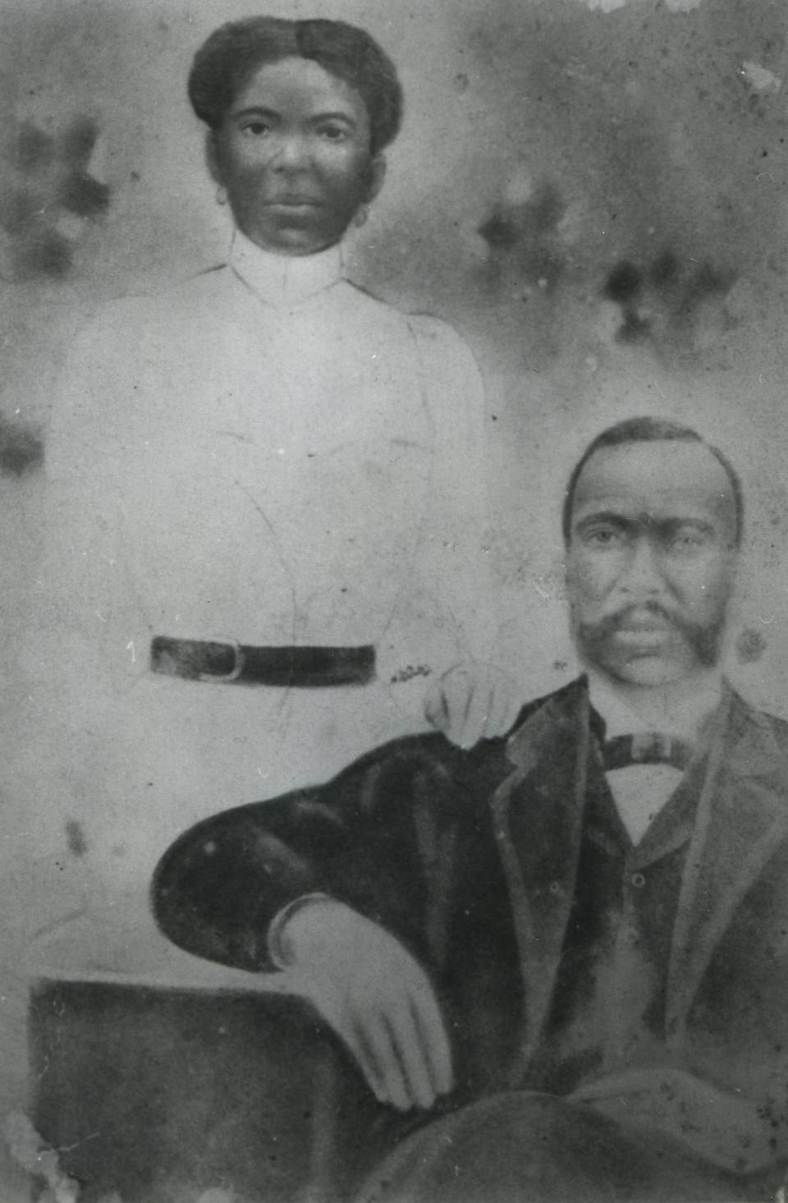MAIN ENTRY

Zora Neale Hurston was born in 1881 in Notasulga, Alabama to John Hurston and Lucy Potts Hurston. Hurston’s mother was a schoolteacher, and her father worked as a carpenter, a Baptist minister; he served two terms as mayor of Eatonville, Florida, Hurston’s adopted hometown. As a young child Hurston attended Hungerford Normal and Industrial School in Eatonville where she recounts developing a love for Norse, Greek, and Roman mythology (39). Hurston’s mother died in 1904 when Hurston was thirteen years old, and her father quickly remarried. That union would prove to provide little support for Hurston and her seven siblings. Hurston was sent to boarding school at the Florida Baptist Academy in Jacksonville, Florida, but eventually her father withdrew financial support. During her formative years, Hurston lived with various family members. She supported herself working as a nanny, a maid with a traveling drama group, a manicurist, a waitress, and a physician’s assistant.In 1918, Hurston began night classes at Morgan College and, under the instruction of Dr. Dwight O. W. Holmes, she decided to enrol formally in high school. After, she attended Howard University’s night preparatory school and then Howard University. Coursework with Dr. Lorenzo Dow Turner while at Howard University confirmed her critical interest in eighteenth century literature and “the roots of the modern novel,” as described in her autobiography, *Dust Tracks on A Road* (1942).

Portrait of John Hurston and Lucy Potts Hurston. http://www.miamiherald.com/entertainment/article1921639.html

Her first published short story, *John Redding Goes to Sea* (1921), was published in *Stylus*, the literary magazine of Howard University. The short story explored the title character’s discontent with the rigid social expectations of his small village, including the pressure to marry and to remain in the rural South, as he yearned to explore the world freely. The story’s themes and narration signalled Hurston’s early interest in experimenting with representations of standard literary English and folk vernacular, and she also used motifs of Southern USA folk religious beliefs and practices to inform the story’s plot. Her poem, ‘O’Night’, was also published in Stylus, and additional poems, ‘Night’, ‘Journey’s End’, and ‘Passion’, were published in *Negro World*, the newspaper of Marcus Garvey’s Universal Negro Improvement Association.

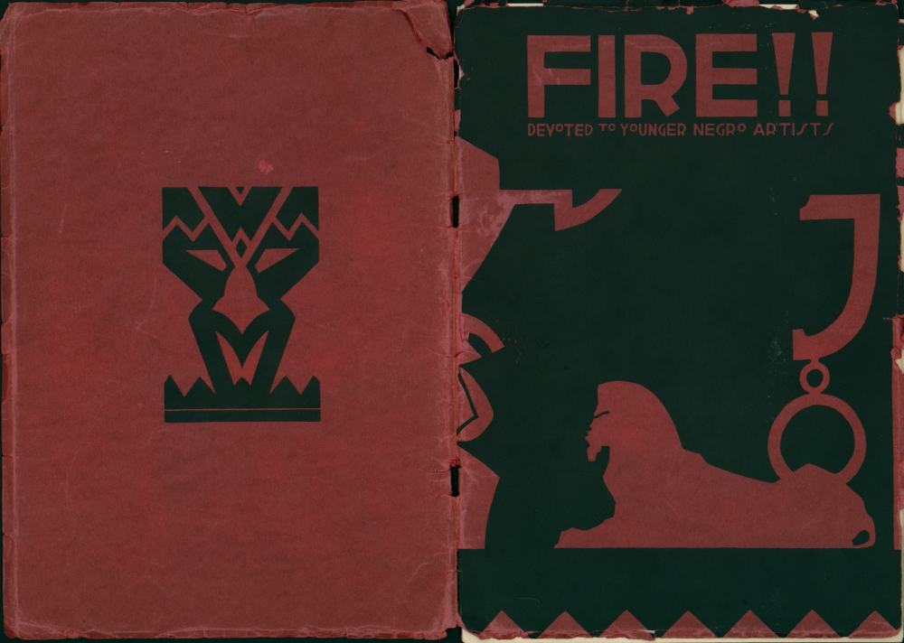In 1925, Hurston, with the aid of a scholarship, began her studies in anthropology at Barnard College with Franz Boas, whose work on race and culture and the development of scientific ethnographic methods modernized the field of American Anthropology. In 1926 Hurston co-founded *Fire!!,* a radical magazineco-founded with, and featuring the works of, Wallace Thurman, Langston Hughes, Aaron Douglas, Gwendolyn Bennett, Richard Bruce Nugent, and John P. David. With the subheading “Devoted to Younger Negro Artists,” *Fire!!* declared its break from the more traditional and conservative artistic representations of black character and life commonly found in the pages of *The Crisis* and *Opportunity: A Journal of Negro Life*, periodicals of the NAACP and Urban League, respectively. The short stories, poetry and plays within *Fire!!* provided frank representations of sexuality, homoeroticism and, in the case of Hurston’s short story ‘Sweat’, a steely portrait of the domestic violence experienced by a young washerwoman in central Florida. Hurston’s other contribution, a play entitled *Color Struck, A Play in Four Scenes,* depicted intra-racism or colorism within the African American community.

Hurston was also a dramatist who authored and staged plays presenting the anthropological data, in both form and content, which she collected during her fieldwork. Her conviction to represent “authentic” work songs and blues songs is considered, by some scholars, evidence of Hurston’s racial essentialism. However, Hurston’s innovation was her replication of specific cultural contexts on the stage, especially when contrasted with the dramatic portraits of Negro life in either stereotypical settings or as highly stylized performances modelled after European choral traditions common at the time.

Cover artwork of *Fire!! by modern artist Miguel Covarrubias.* http://www.hrc.utexas.edu/exhibitions/education/modules/teachingthetwenties/assets/txu-hrc-0003a/txu-hrc-0003a-1000.jpg

Prior to publishing her first novel, *Jonah’s Gourd Vine* (1934), Hurston completed ethnographic fieldwork in Florida and New Orleans during the late 1920s, which she later compiled and organized for later publication as *Mules and Men* (1935). The ethnography featured the data she collected from residents of local sawmill and turpentine camps in Polk County, Florida, and from several hoodoo practitioners in New Orleans. *Mules and Men* is often critically regarded as a highly experimental social scientific work because of its use of first person narration (auto-ethnography) and other conventions of literary narrative, such as highlighting the dialogue between herself and her interviewees. It is also noted for its systematic transcriptions of USA southern folk vernacular. Published a year later, *Jonah’s Gourd Vine* drew from the biographies of her parents in its characterization of John Pearson, a man called to preach but tempted by infidelity. Although the novel represents issues related to racism and colorism, particularly in its depictions of the experiences of a family one-generation removed from American slavery, the novel significantly foregrounds the inner psychology of her characters. In this way, Hurston moved away from the concern of many of the era’s race leaders that Negro art should strive to foreground race and racism as a central problem within their works.

A 1939 recording of Hurston singing “Shove it Over,” a Iining song that she collected during her fieldwork in the sawmill and turpentine camps in Florida in 1933. Hurston made this recording while employed by the Federal Writer’s Project in Jacksonville, Florida.

<http://memory.loc.gov/afc/afcflwpa/313/3136a1.mp3>

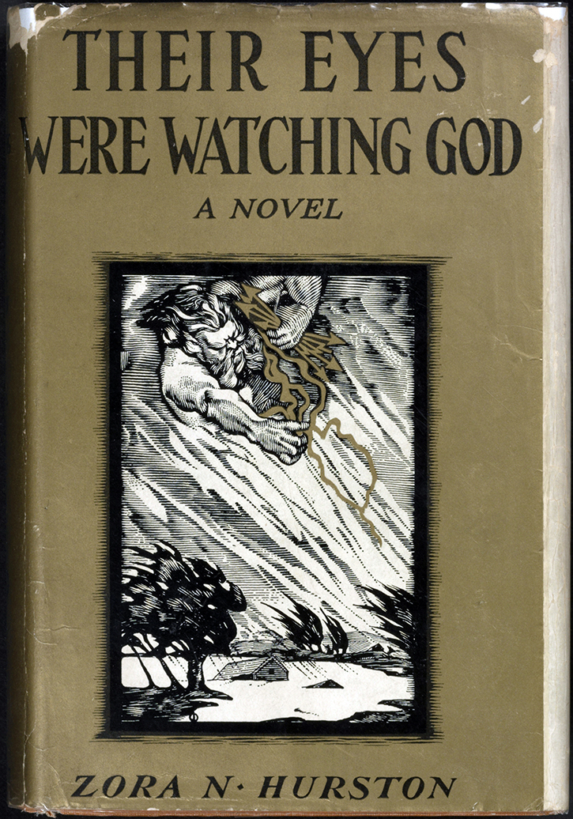*Their Eyes Were Watching God* (1937), Hurston’s most celebrated work, was written while Hurston completed fieldwork in Haiti and Jamaica on a Guggenheim fellowship awarded the previous year. Set in the southern U.S., the novel also includes allusions to Vodun folk customs and cosmology. The novel is modern in its attention to themes related to gender and sexuality and in its experimentation with literary form and narration. For example, Hurston’s use of free-indirect discourse through the blending of folk-vernacular with standard English from a third- person point of view is often noted as a singular innovation in the African American literary tradition.

Original book jacket for Their Eyes Were Watching God: A Novel. Rare Book and Special Collections Division, Library of Congress (056.00.00) http://www.loc.gov/exhibits/books-that-shaped-america/1900-1950/Assets/ba0056_enlarge.jpg

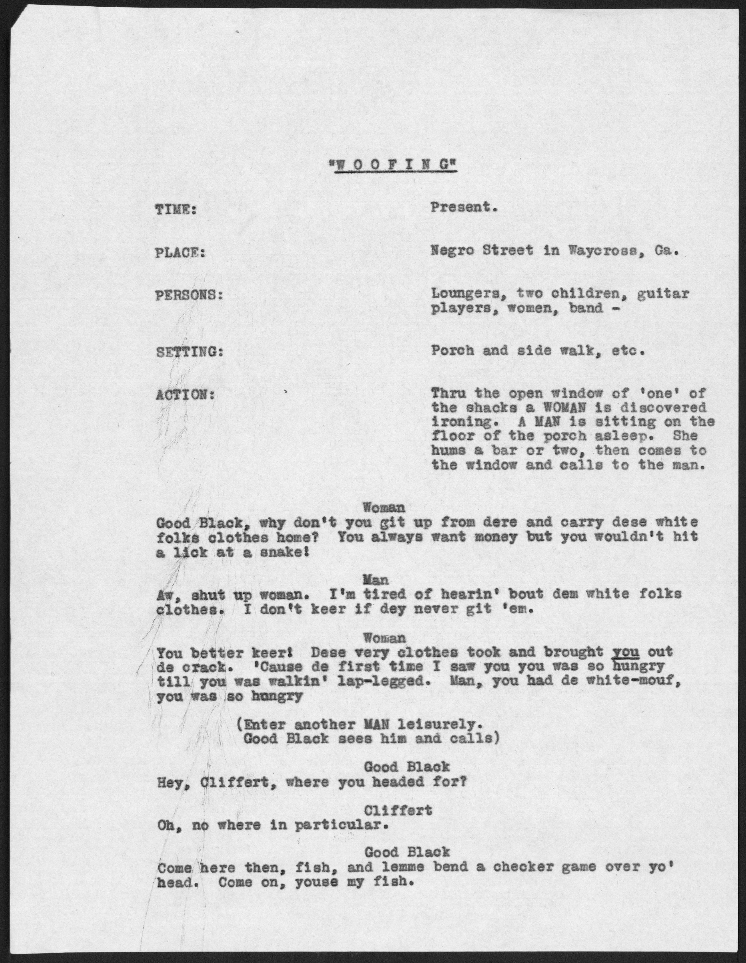In *Moses, Man of the Mountain* (1939) Hurston significantly revises the Old Testament narrative of Moses as a “folklore novel.” Noting the prominence of the figure of Moses in folk-religions throughout the world, Hurston’s Moses is endowed with the agency and characteristics of the hoodoo doctors she researched in New Orleans, and her biblical characters speak in vernaculars of the southern United States. Hurston’s second ethnography, *Tell My Horse (1939),* waspublished in the same year. The ethnography’s blurring of literary and ethnographic conventions has led scholars to refer to the work as a travelogue, especially since, as in *Mules and Men*, Hurston featured dialogues between herself and her interviewees and included first person narrations of her impressions of cultural phenomena in both Caribbean locales. Hurston’s final novel, *Seraph on the Suwanee* (1948), attempted to break through the color line in USA fiction, which relegated black authors to writing about black subjects and characters. Hurston figured its central characters, including Arvay and Jim Henson, as white and southern-born Floridians who, seemingly, speak with the same vernacular as the black characters in her earlier fictions. In addition, critics have noted Hurston’s critique of marriage and references to Freudian psychology in her characterizations in the novel.

Collected Works

*Folklore, Memoirs, & Other Writings: Mules and Men, Tell My Horse, Dust Tracks on a Road, Selected Articles* (Cheryl A. Wall, ed.) (Library of America, 1995)

*Novels & Stories: Jonah's Gourd Vine, Their Eyes Were Watching God, Moses, Man of the Mountain, Seraph on the Suwanee, Selected Stories* (Cheryl A. Wall, ed.) 1995

*Zora Neale Hurston: Collected Plays* (Multi-Ethnic Literatures of the Americas (MELA) (2008)

*Woofing* play script authored by Zora Neale Hurston. <http://www.loc.gov/resource/mhurston.0107/?sp=1>

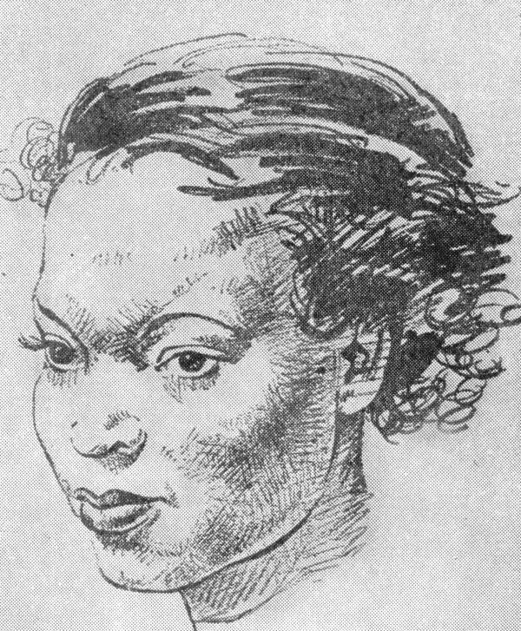Novels

*Jonah’s Gourd Vine (1934)*

*Their Eyes Watching God (1937)*

*Moses, Man of the Mountain (1939)*

*Seraph on the Suwanee (1948)*

Short story collections

*SPUNK: Three Tales by Zora Neale Hurston* (1944)

*The Complete Stories* (1995)

Drawing of Zora Neale Hurston by George Schreiber (1904-1977)included with review of Hurston’s Autobiography *Dust Tracks on A Road* (1942) in *The Saturday Review*.

Drama (selected)

*Meet the Mamma: A Musical Play in Three Acts* (1925)

*Cold Kenner, A Revue* (1930)

*De Turkey and de Law: A Comedy in Three Acts* (1930)

*The Mule-Bone: A Comedy of Negro Life in Three Acts (1931) (co-authored with Langston Hughes)*

*Forty Yards* (1931)

*Lawing and Jawing* (1931)

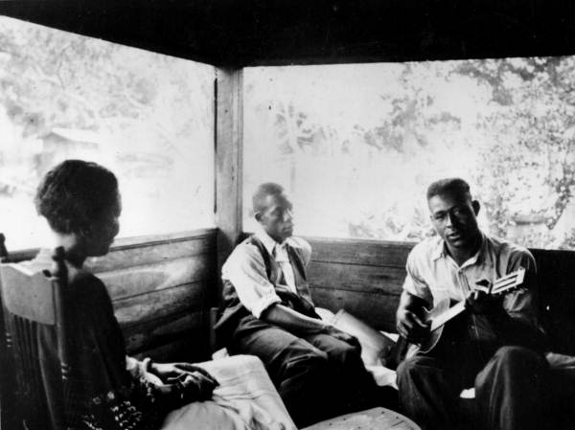*Poker!* (1931)

*Woofing* (1931)

*Spunk* (1935)

*Polk County: A Comedy of Negro Life on a Sawmill Camp with Authentic Negro Music in Three Acts* (1944)

Essays (selected)

The Eatonville Anthology (1926)

How It Feels To Be Colored Me (1928)

Characteristics of Negro Expression (1934)

Work-In-Progress For: The Florida Negro (1938)

The Pet Negro System (1943)

Hurston collecting folklore from Gabriel Brown (playing guitar) and Rochelle French. State Archives of Florida, Florida Memory. Reproduced from the collection of the Library of Congress. <http://floridamemory.com/items/show/107444>

High John de Conquer (1943)

Negroes Without Self-Pity (1943)

My Most Humiliating Jim Crow Experience (1944)

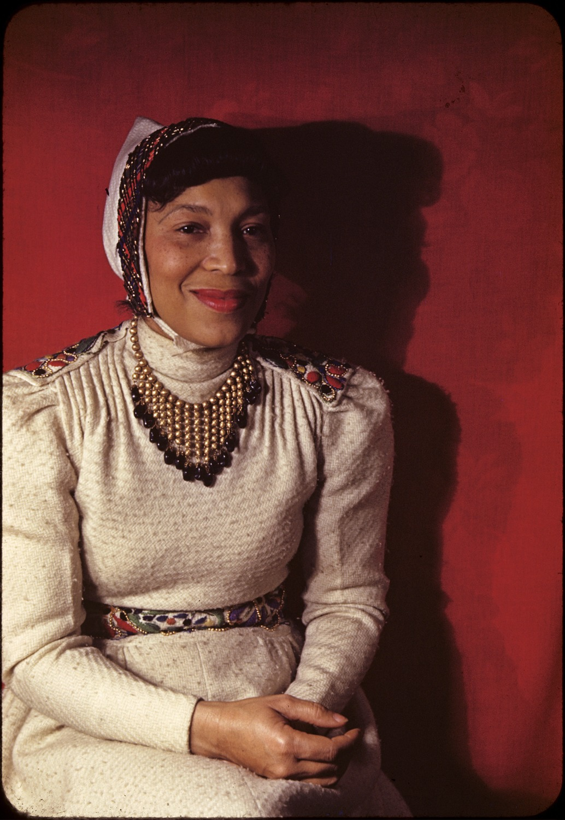The Rise of the Begging Joints (1945)

Crazy for This Democracy (1945)

What White Publishers Won't Print (1950)

Court Order Can't Make Races Mix (1955)

Biography

*Zora Neale Hurston: A Literary Biography* (1977)

*Wrapped In Rainbows: The Life of Zora Neale Hurston* (2003)

*Zora Neale Hurston: A Biography of the Spirit* (2007)

*Zora Neale Hurston’s Final Decade* (2011)

Autobiographical writings and diaries

*Dust Tracks on a Road: An Autobiography (1942)*

Letters

Photo by Carl Van Vechten

<http://brbl-media.library.yale.edu/images/1074693_quarter.jpg>

Zora Neale Hurston: A Life in Letters (Carla Kaplan, ed.) 2003

Ethnography

*Mules and Men* (1935)

*Tell My Horse: Voodoo and Life in Haiti and Jamaica* (1939)

**Further reading**

Duck, L. (2006). *The nation's region : Southern modernism, segregation, and U.S. nationalism* (New southern studies). Athens: University of Georgia Press.

Gates, H., & Appiah, A. (1993). *Zora Neale Hurston : Critical perspectives past and present* (Amistad literary series). New York: Amistad : Distributed by Penguin USA.

Hurston, L. (2004). *Speak, so you can speak again: The life of Zora Neale Hurston* (1st ed.). New York: Doubleday.

Hutchinson, G. (1995). *The Harlem renaissance in black and white*. Cambridge, Mass.: Belknap Press of Harvard University Press.

Jennings, La Vinia Delois (2013). Zora Neale Hurston, Haiti, and *Their eyes were watching God*. Evanston, IL.: Northwestern University Press.

Wall, C. (2000). *Zora Neale Hurston's Their eyes were watching God : A casebook* (Casebooks in contemporary fiction). Oxford ; New York: Oxford University Press.

Jennifer Freeman Marshall, Purdue University